NAAN MUDHALVAN ASSIGNMENT DOCUMENT

**COURSE TITLE** : DIGITAL MARKETING

**COLLEGE CODE :** 1105

**COLLEGE NAME** : GOJAN SCHOOL OF BUSINESS AND TECHNOLOGY

**NM ID** : A8BA455EC6244E493F346AB604D4D6E1

**NAME** : RANKESH N

**REGISTER NUMBER** : 110520106332

**YEAR** : 4TH YEAR

**DEPARTMENT** : ELECTRONICS AND COMMUNICATION ENGINEERING

1. Create a blog or website using Blogspot and Wordpress. Customize the theme design and post new article with 500 words.

Link <https://footballphileequipment.blogspot.com/2023/10/fb-club.html>



1. Create a New Facebook Business Page and post one social media poster for your brand.

Link: <https://www.facebook.com/people/Footballgame-Footballgame/pfbid05woyBDV5KyoFsd8QZwGD8SqZSCP4Yfxxn4CZcqtSFRGZjb5zNWpgQUiFwjtm1MVVl/?mibextid=ZbWKwL>

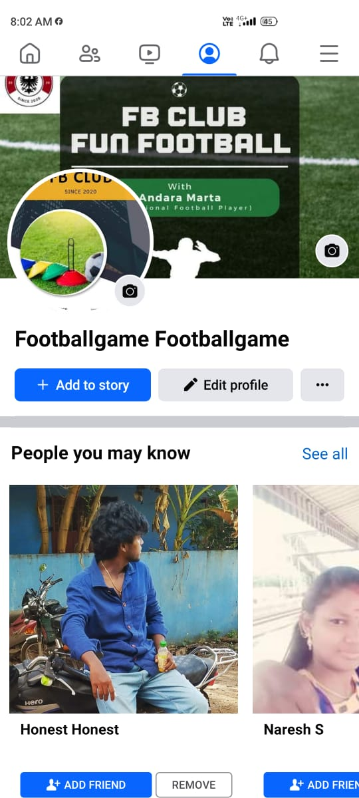  
Create and design a social media advertisement poster using canva.

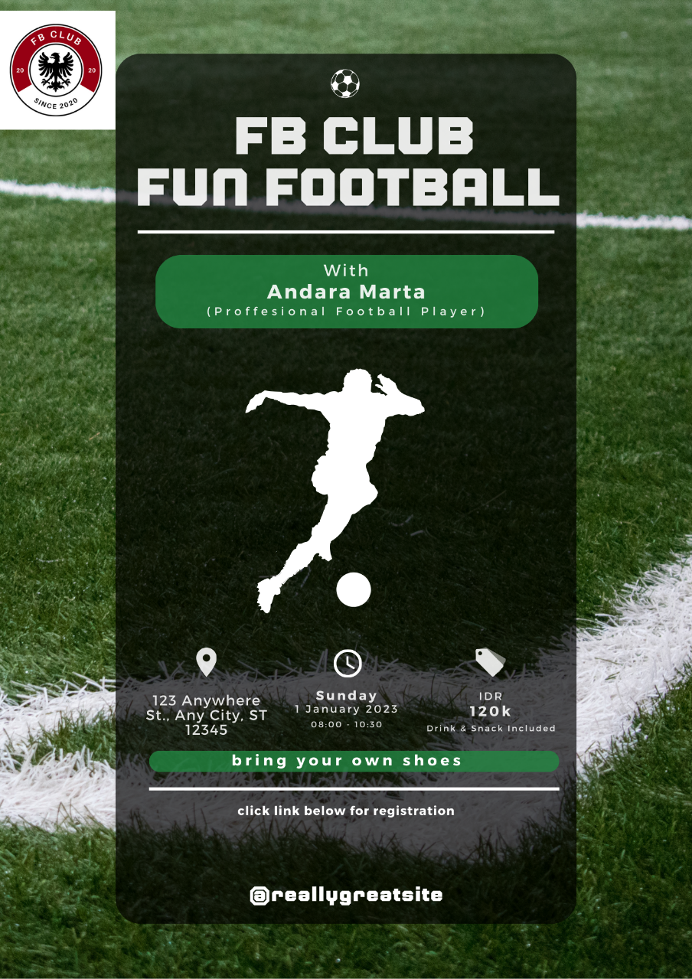

1. Create email newsletter design using MailChimp or canva tool.

Link: <https://www.canva.com/design/DAFySVYE2uQ/nc6mrM1ysiqL9foc-HvW9A/view?utm_content=DAFySVYE2uQ&utm_campaign=share_your_design&utm_medium=link&utm_source=shareyourdesignpanel>

